

Literature Review

Project Report: Home

Rental System

Student Id : 2358569

Student Name : Amit Babu Khatri

Group : L4CG19

Supervisor : Mr.Johan Tandukar

Reader : Mr. Aatiz Ghimire

Submitted On : 12/27/2024

## Contents

Design and Development of Smart House Rental Management System 5

A secure blockchain-based housing rental platform 7

Research on Customer Attention of Online Short-term Rental Platform 8

RENTAL HOUSE MANAGEMENT SYSTEM 10

SIMILAR REALTED WORK 11

References 14

## Table of Figure

Figure 1: Reality Nepal .................................................................................................. 15

Figure 2: NepalHomes .................................................................................................. 16

Figure 3: Rentals ........................................................................................................... 17

## Real Estate Management System of Personal Seekers for Investment Decision

Real Estate Management System of Personal Seekers for Investment Decision - Real estate management systems are increasingly utilized by buyers, investors, and property owners to effectively manage portfolios and search for investment opportunities. This article discusses the creation of a personalized real estate management system aimed at fulfilling the needs of individual property seekers. (Temdee, 2022)

Current Real Estate Websites - Websites like DDproperty.com and Feasy-online.com allow property listings but lack the capability to provide consolidated listings from various sources. These platforms also do not offer long-term data storage or maintenance. Mobile applications like HomeSeeker improve search functionalities but still lack personalized features for property matching.

Personalized System Features - Unlike existing systems, no platform was specifically created for individual property seekers to manage homes for investment. The system's development focused on features such as storing discovered properties, adding custom data, location-based navigation, and property sharing. User interviews informed the design and helped incorporate ideas from personal information management for investment analysis.

Technologies Used - The application was developed using a MySQL database along with the appropriate frontend and backend technologies. Both the frontend and backend were designed with user-friendliness and a consistent data model in mind to ensure smooth usability.

System Evaluation - The system underwent extensive testing to ensure its specifications were met. A user satisfaction survey based on the Technology Acceptance Model was used to evaluate aspects like design, structure, functionality, and overall usability.

Real estate management systems are being used more and more by buyers, investors, and property owners to efficiently manage their portfolios and look for new investment opportunities. The creation of a personalized real estate management system to satisfy the requirements of certain property seekers is covered in this article.

Current real estate websites, such as DDproperty.com and Feasy-online.com, permit listings but do not provide separate collections from different sources. Although they lack long-term data storage and maintenance, mobile apps like HomeSeeker improve search capabilities. Personalized characteristics are absent from certain systems, even when they provide property matching. To conserve and manage homes for investment, no system was created especially for individual property hunters. Key features including storing discovered properties, adding custom data, location-based navigation, and property sharing were the emphasis of the system's development, which involved user interviews. For customized data collecting and investment analysis, it integrated ideas from personal information management. (Chongdarakul, 2022)

A MySQL database and the proper frontend and backend technologies were used in the development of the applications. Both interfaces were made with user-friendliness and a consistent data model in mind. Extensive testing was carried out and the system specifications were followed. Design, structure, functionality, and usability were evaluated by a user satisfaction survey that was based on the Technology Acceptance Model.   
  
Conclusion - The study emphasizes the growing need for personalized real estate management systems tailored to individual property seekers. Unlike current platforms, which lack consolidated listings and personalized features, the proposed system focuses on custom data storage, location-based navigation, and property sharing. By integrating insights from user interviews and personal information management, the system aims to enhance investment analysis and meet the unique needs of property investors.

# Design and Development of Smart House Rental Management System

In their 2020 study on HRMS development, Ikuomola and Asefon created a mobile cloud-based system that lets tenants look for houses and connect with landlords via chat, rental posting, and search features, eliminating the need for manual record-keeping. In order to control door access in vacation rental management—a feature that is lacking from most modern systems—Check-Yee et al. (2020) integrated a smart lock. Anif et al. (2021) used a genetic algorithm to track demand and usage in real-time for an automobile rental scheduling app. Delphi and Tian (2010) collaborated to develop a system for managing shared property, but it had functional issues. Ye (1999) created a web-based workflow system for a car rental company that included secure data storage. (Ikuomola, 2020)

In order to overcome constraints, the following crucial elements of an intelligent HRMS are recommended: (1) Landlords and brokers can easily add, remove, or modify tenant and property details thanks to an intuitive interface. (2) Rent is collected using automated payment tracking and late payment reminders. (3) Property expenses and maintenance requests are documented to aid in decision-making. (4) Access control is integrated with smart locking functions. (5) Reports include information on the state of money, properties, and tenants. (al, 2021)

PHP and MySQL were used in the development of the system, together with front-end web technologies like HTML, CSS, and JavaScript. Features include smart locking, maintenance requests, rent/payment modules, tenant and property profiles, user identification, and reporting. Simplicity was guaranteed by the use of UX design principles. Extensive testing verified functioning and performance before deployment.

HRMS Development for Real Estate Management - In their 2020 study, Ikuomola and Asefon developed a mobile cloud-based system that enables tenants to search for houses and interact with landlords through features like chat, rental posting, and search, thereby eliminating the need for manual record-keeping.

Smart Lock Integration in Vacation Rental Management - In 2020, Check-Yee et al. introduced a smart lock to control door access in vacation rental management systems, a feature that was missing in most contemporary systems at the time.

Automobile Rental Scheduling with Genetic Algorithm - Anif et al. (2021) employed a genetic algorithm to track real-time demand and usage in an automobile rental scheduling app, offering a dynamic solution for resource management.

Shared Property Management System by Delphi and Tian - In 2010, Delphi and Tian collaborated to develop a system for managing shared property, though it faced functional issues that impacted its overall effectiveness.

Web-Based Workflow System for Car Rental - Ye (1999) created a secure web-based workflow system for a car rental company that included safe data storage, addressing the challenges of managing rental data online

**Technologies Used** - The system was developed using PHP and MySQL, along with front-end web technologies such as HTML, CSS, and JavaScript. Features include smart locking, maintenance requests, rent/payment modules, tenant and property profiles, user identification, and reporting. The use of UX design principles ensured simplicity and user-friendliness. Extensive testing confirmed the system's functionality and performance before deployment.

Conclusion - The study highlights the development of an intelligent HRMS that incorporates key features like automated rent collection, smart lock integration, property management, and real-time data tracking to improve efficiency in rental management. By utilizing PHP, MySQL, and front-end technologies, the system simplifies processes for landlords and tenants through intuitive interfaces and user-friendly design principles. The inclusion of features like maintenance requests and reporting ensures a comprehensive and effective solution. Extensive testing confirms the system's functionality, making it a promising tool for modern property management.

# A secure blockchain-based housing rental platform

Blockchain technology has the potential to completely transform a number of industries since it makes trustless transactions possible without the need for middlemen. The rental housing industry presents unique challenges that blockchain technology may be able to address. A lack of trust between landlords and tenants, high transaction costs caused by middlemen, and privacy concerns concerning sensitive data are just a few of the serious problems with the traditional housing rental system. (Yu, 2021)

The authors developed a home rental concept that combines regular users, landlords, tenants, and a blockchain network. Landlords provide details about their houses and tenants search for homes on the web. An essential precondition is the implementation of zero-knowledge proofs to confirm user identities on the blockchain network. This enables user credentials to be verified without revealing personal information.

A blockchain-based solution for house rentals that eliminates middlemen, reduces expenses, automates procedures using smart contracts, and guarantees information verification for landlords while protecting privacy is presented in the literature's conclusion. Despite being hypothetical, the idea shows how blockchain technology could revolutionize the leasing industry and foster participant trust. Implementing and testing this solution on an actual platform could be a future development. (Zhang, 2021)

Blockchain Technology in the Rental Housing Industry - Blockchain technology has the potential to revolutionize multiple industries by enabling trustless transactions without the need for intermediaries. The rental housing industry, in particular, faces unique challenges such as a lack of trust between landlords and tenants, high transaction costs due to middlemen, and privacy concerns related to sensitive data. Blockchain may offer solutions to these issues.

Home Rental Concept with Blockchain Integration - The authors introduced a home rental concept that integrates regular users, landlords, tenants, and a blockchain network. In this model, landlords provide details about their properties, and tenants search for available homes online. A key component of this system is the use of zero-knowledge proofs to verify user identities on the blockchain network. This approach allows for the validation of user credentials without disclosing any personal information.

Blockchain-Based Rental Solution - The proposed blockchain-based solution aims to eliminate middlemen, reduce transaction costs, automate processes using smart contracts, and ensure information verification for landlords while maintaining privacy protection. The concept, although hypothetical, demonstrates how blockchain could transform the housing rental industry by fostering trust among participants.

Future Developments - While the idea remains theoretical, it outlines the potential for blockchain technology to revolutionize the leasing industry. Future developments could involve the implementation and testing of this solution on actual rental platforms to assess its viability and impact.

Conclusion - The study presents a blockchain-based solution for the rental housing industry, addressing key challenges such as lack of trust, high transaction costs, and privacy concerns. By integrating landlords, tenants, and a blockchain network, the proposed system ensures secure, trustless transactions through features like zero-knowledge proofs for identity verification and smart contracts for automating processes. This concept could significantly reduce the reliance on intermediaries and enhance privacy for all participants. While still hypothetical, it demonstrates the transformative potential of blockchain technology in revolutionizing the leasing industry and fostering trust. Future testing and implementation on an actual platform could validate its effectiveness.

# Research on Customer Attention of Online Short-term Rental Platform

On Piggy, a well-known short-term rental website, the researchers examined 87 evaluations from ten of China's most visited tourist destinations. They used ROST content mining algorithms to find important topics in the reviews. Property comfort, including space, quietness, cleanliness, and décor, was ranked as a top priority by 58% of respondents. Customers favor distinctive, comfortable interiors over typical hotels, indicating a need for a wider range of lodging choices. (Meng, 2018)

With 1,046 instances of "landlord" in reviews, the study emphasizes the significance of landlord service and demonstrates how highly regarded traits like zeal, commitment, and empathy are. Customers emphasize the social component of short-term rentals and view the landlord-tenant relationship as a primary differentiation from regular hotels. In order to promote customer satisfaction and platform growth, the report recommends upgrades like distinctive designs, landlord training, fully equipped rooms, and upmarket locations. Even though the study only looked at one Chinese operator, the results provide information on consumer preferences for sharing economy lodging and may lead to more extensive studies in the future. (Xu, 2018)

Research on Customer Attention of Online Short-Term Rental Platforms - In a study conducted on Piggy, a well-known short-term rental website, researchers analyzed 87 reviews from ten of China’s most visited tourist destinations. They employed ROST content mining algorithms to identify key themes in the reviews, shedding light on customer preferences and expectations in the short-term rental market.

Property Comfort as a Priority - According to the study, property comfort was identified as a top priority by 58% of respondents. Key aspects of comfort, such as space, quietness, cleanliness, and décor, were highlighted as the most important factors. Customers expressed a preference for unique, comfortable interiors over standard hotel offerings, indicating a demand for a more diverse range of lodging options.

Importance of Landlord Service - The study also highlighted the critical role of the landlord in short-term rental experiences, with 1,046 mentions of the word "landlord" in the reviews. Traits such as enthusiasm, commitment, and empathy were highly valued, showing that customers perceive the landlord-tenant relationship as a key differentiator from traditional hotel stays. The social aspect of short-term rentals was emphasized as a vital part of the overall experience.

Recommendations for Platform Improvement - To enhance customer satisfaction and foster platform growth, the report suggests several upgrades, including offering distinctive property designs, providing landlord training, ensuring fully equipped rooms, and selecting premium locations. Though the research focused on a single Chinese operator, its findings provide valuable insights into consumer preferences in the sharing economy lodging sector and could inspire further studies.

In conclusion, the literature identified significant experience characteristics for the short-term rental industry by methodically mining online reviews. Comfort, service, facilities, and location have been recognized as essential customer touchpoints to better meet emerging consumer demands in this growing market area.

# RENTAL HOUSE MANAGEMENT SYSTEM

In India, where more than 30% of people reside, renting a home is increasingly a feature of contemporary urban living, according to national census data. Both landlords who oversee rental properties and tenants looking for housing currently perform the majority of tasks by hand, according to the report. Both parties have challenges as a result of this.

Important problems with the current renting system are highlighted in the literature. According to Indian study, many low-income people are unable to pay their rent each month and frequently struggle to afford rental housing (NSSO, 2010). States like Andhra Pradesh, Tamil Nadu, and Karnataka have rental occupancy rates that are higher than the national average, whereas states like Bihar and Uttar Pradesh have rates that are lower than 20%. These regional differences are also noticeable (NSSO, 2010). There is a dearth of empirical study on rental data in India, in contrast to global studies on platforms such as Airbnb that examine relational benefits and factors influencing renter selections. (Ikuomola & Asefon, 2020).

According to the findings, the new framework establishes an effective online marketplace that makes it simple for landlords and renters to locate compatible properties based on factors like amenities, cost, and location. In contrast to more conventional approaches, users can browse listings, alter rental statuses, and speak with owners directly, making operations simpler. In order to enhance the system's quality going forward, an examination of 1987 evaluations from a significant Chinese rental website identified important customer criteria, including location, comfort, facilities, and service.. (Meng & Xu, 2021).

Conclusion - The study highlights the growing significance of renting in urban India, with challenges faced by both landlords and tenants due to manual processes. Regional disparities in rental occupancy and affordability issues for low-income individuals are noted, with a lack of empirical research on rental data in India compared to global studies. The proposed framework introduces an effective online marketplace, simplifying property search, communication, and listing management. Drawing from customer feedback on a major Chinese rental platform, key criteria like location, comfort, facilities, and service are emphasized for improving system quality and meeting evolving consumer needs in the rental market.

# SIMILAR REALTED WORK

**Reality Nepal:** One of the most well-known real estate websites in the nation is Realty Nepal, which is divided into several divisions with unique features. In addition to showing properties by location for convenient browsing, it has a search feature that lets users identify properties using keywords. To access the entire system and investigate other features, users must first register. There are also pertinent stories in the "News" section of the website. When examining properties, consumers may see all relevant information together with the property's location on a map.

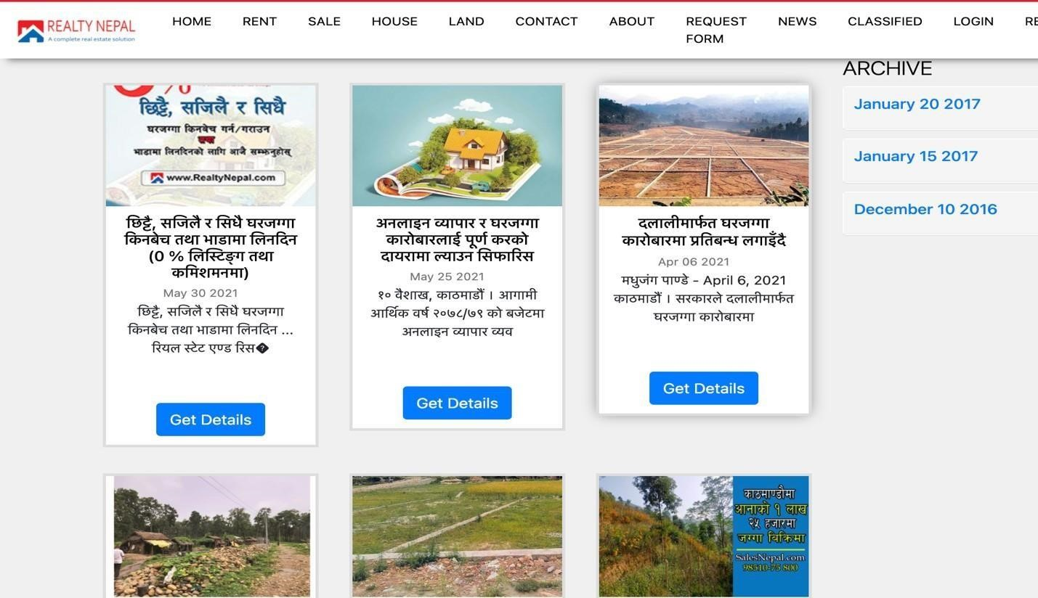

*Figure 2: Reality Nepal*

**NepalHomes:** Because of its easy-to-use layout, NepalHomes is regarded as one of the top real estate websites in Nepal. It provides a range of services for home purchase or renting, finance, and real estate marketing. The "News" section provides users with up-to-date information on recent occurrences, while the search box allows them to look for homes. In addition to offering a recommendations area that suggests other homes to look at, the website lets users categorize residences according to several criteria.

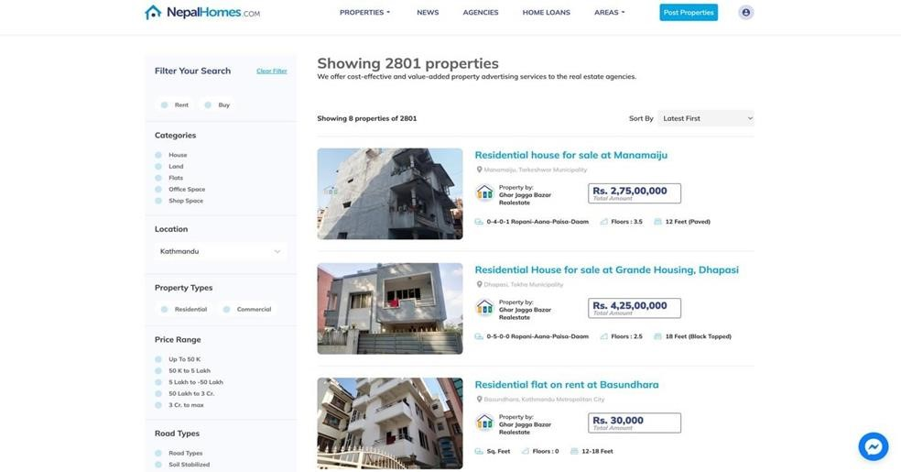

*Figure 3: NepalHomes*

**Rentals:** One of the best international real estate websites, Rentals, lets customers look for homes and properties in their area. Users may see the location of the property on a map thanks to Google Maps integration. Landlords and tenants have different registration procedures. Additionally, the website has a "Blog" area containing a variety of topics. Users can view the location and all pertinent property details on a map while perusing properties.

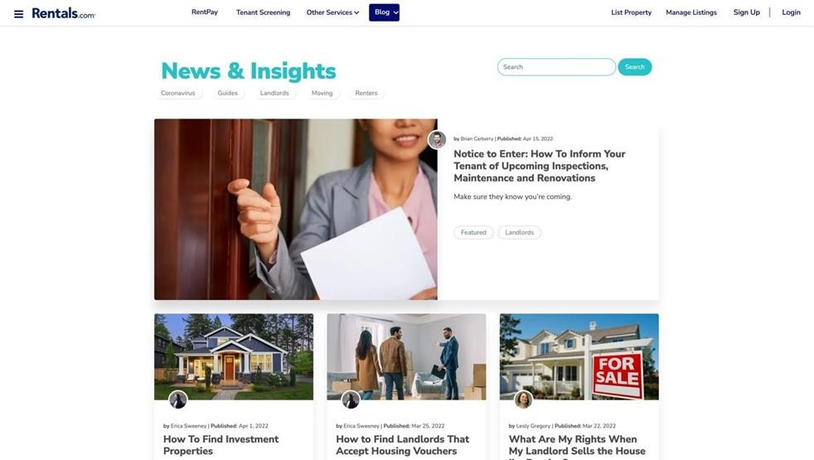

*Figure 4: Rentals*

##### 

Comparison with similar system in Table Form

|  |  |  |  |  |  |
| --- | --- | --- | --- | --- | --- |
| Features | Basobaas | | Reality Nepal | Rentals | comparison (my website) |
| Attractive UI |  | **Yes** | **No** | **Yes** | **Yes** |
| Easy navigation |  | **Yes** | **Yes** | **Yes** | **Yes** |
| Blog section |  | **Yes** | **Yes** | **Yes** | **Yes** |
| Booking |  | **No** | **No** | **No** | Yes |
| Map |  | **No** | **No** | **Yes** | Yes |
| Display list property | of | **Yes** | **yes** | **Yes** | **Yes** |
| Search feature |  | **Yes** | **Yes** | **Yes** | **Yes** |
| Notification |  | **Yes** | **No** | **Yes** | **Yes** |
| User-Profile |  | **Yes** | **Yes** | **No** | **Yes** |

# References

W. Chongdarakul, N. Rongbutsri and P. Temdee, "Real Estate Management System of Personal Seekers for Investment Decision," 2022 Joint International Conference on Digital Arts, Media and Technology with ECTI Northern Section Conference on Electrical, Electronics, Computer and Telecommunications Engineering (ECTI DAMT & NCON),  
  
<https://www.researchgate.net/publication/330227604_Research_on_Customer_Attention_of_Online_Short-term_Rental_Platform>  
  
<https://www.researchgate.net/publication/372213867_Design_and_Development_of_Smart_House_Rental_Management_System>